PROVIDER ELECTRONIC SOLUTIONS SOFTWARE UPGRADE INSTRUCTIONS 4.03 – WEB

Note: Please disable all Anti-Virus software before proceeding with the installation or upgrade of the PES software.
Important note for users applying the upgrade. Prior to running the upgrade complete the following:
Make sure all claims have already been submitted. DO NOT have any claims that are in “Incomplete” or “Ready” status.
Please Archive claims that are in a Final status.
Create a copy of the Database (panewecs.mdb) and save it so that you have a back up of your database.

- Click on one of the following buttons on the DHS website:
Download the software upgrade 4.03
Download the software upgrade 4.02
Download the software upgrade 4.01

- You will be prompted to save the file to a location on your computer similar to the picture below. Click on the Save As button.

- 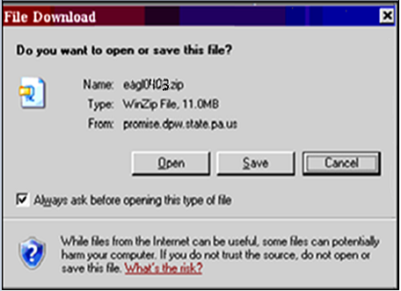
- 3. Browse to the location you wish to save the file. You need to save the file to the appropriate papromise folder.
            - Upgrade 4.01 and 4.02 to C:\papromise\upgrades
            - Update 4.03 to C:\papromise
          - (ex: C:\papromise) Click Save As to download the file and save it to the location you indicated.

- Once the file successfully downloads, you will need to apply the upgrade. To do this, go to your Start Menu, Programs, PA PROMISe Provider Electronic Solutions Software, Upgrades. This will launch the upgrade program similar to the picture below.

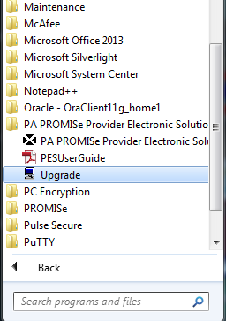

- The following message will display. Click Next . The upgrade process will complete
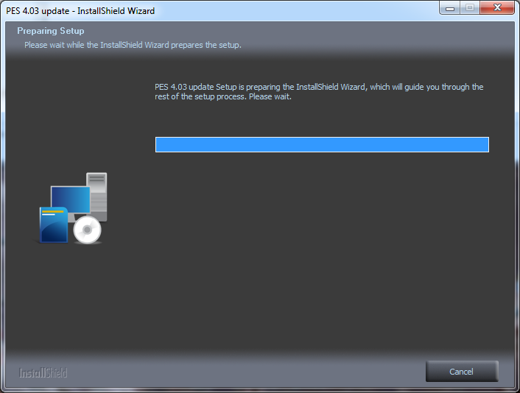

- Click Next . The upgrade process will complete. Once the process is finished, the following screen will display.
- 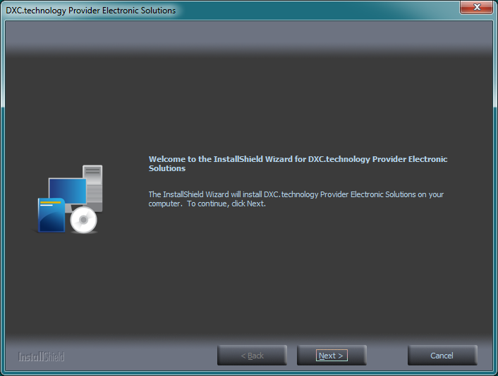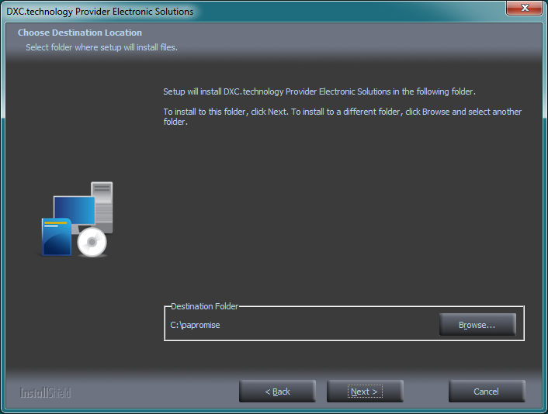

- Click Finish . The upgrade has been successfully added to your installation of the Provider Electronic Solutions software. You can now log in, using your current User ID and Password and begin using the software.
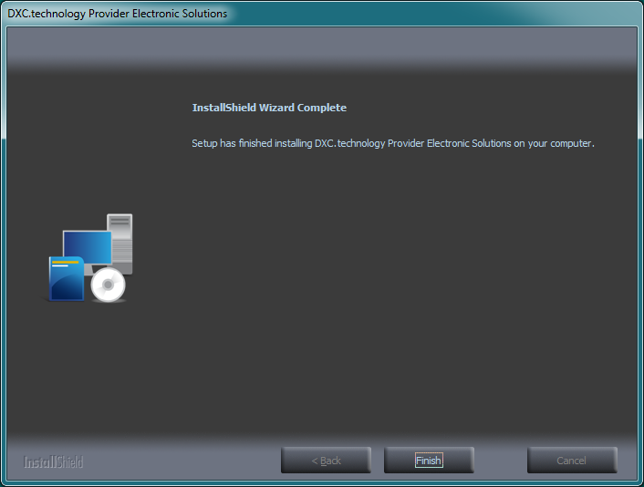

Note: Use of software for purposes other than intended or any altering of software, such as files being loaded into the software, are not supported by the DXC Technology EDI Department.

Notice: The information contained in this software should be guarded in accordance with the Health Insurance Portability and Accountability Act of 1996 - Privacy Rule 45 CFR Part 164. It is the responsibility of the Covered Entity as well as it's Business Associates to comply with HIPAA Privacy and Security standards in order to safeguard individually identifiable information and protected health information.

